LAM

LLM = Thinks
LAM = Does

Why was LAM introduced?
Imagine ChatGPT.
You ask
"What's the weather?"
It replies
"30°C"
Great.
Now ask
"Book me a flight to Delhi."
An ordinary LLM replies
"Sure. Visit MakeMyTrip."
It cannot actually book.
Why?
Because
LLM only generates text.
It cannot
- click buttons
- login
- search websites
- call APIs
- fill forms
- upload files
- buy tickets
It has no hands.
It only predicts words.

Definition
A Large Action Model is an AI model that understands a user's goal, plans the required steps, and performs actions using software, APIs, tools, browsers, databases, or devices.
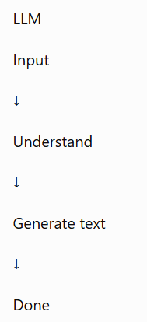

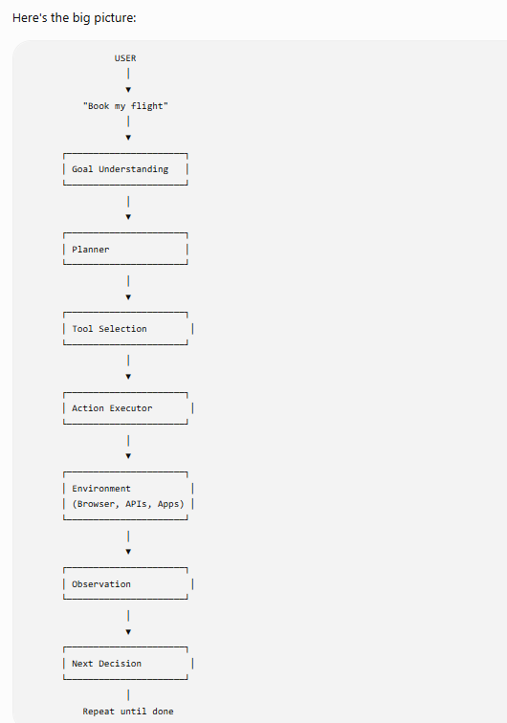

Let’s use one example throughout
User request:
“Schedule a meeting with Rahul tomorrow at 3 PM and send him an invite.”
This is a perfect LAM example because it requires multiple actions.
The AI must:
- Understand the request
- Check the calendar
- Find a free slot
- Create the meeting
- Add Rahul as attendee
- Send invitation email
- Confirm completion
An ordinary LLM may explain how to do it.
A LAM actually performs it.

What happens?
The user gives a natural language instruction.
Input
“Schedule a meeting with Rahul tomorrow at 3 PM and send him an invite.”
The LAM first converts this into structured information.
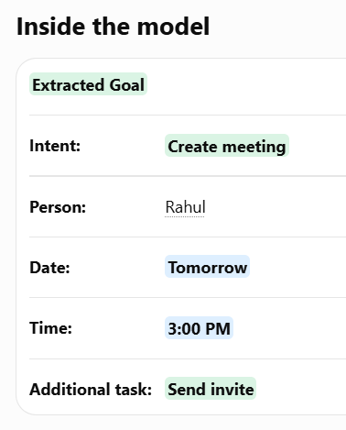

Step 2 — Planner
Now the LAM asks:
“What sequence of actions will achieve this goal?”
This is the planning stage.
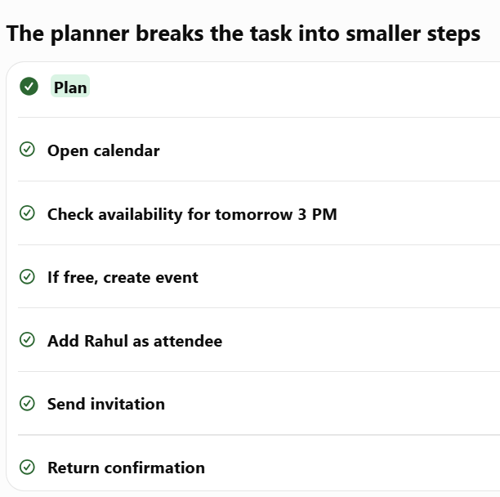
Why planning matters
Without planning, the AI might try to create the meeting before checking availability.
Good planning prevents mistakes.
The planner may also handle conditions
If 3 PM is busy:
- Find next available slot
- Ask user for confirmation
- Then create meeting
So planning is not just a fixed list.
It can include conditions, branches, retries, and decisions.

Step 3 — Tool Selection
Now the LAM knows what to do.
Next it asks:
“Which tool should I use?”
Available tools
Task | Tool
Calendar access | Google Calendar API
Send email | Gmail API
Open browser | Browser automation
Search website | Browser tool
Read database | Database tool
The LAM chooses
Selected tools
Google Calendar API
Gmail API
Important idea
The LAM does not directly manipulate the calendar.
It calls a tool that has permission to do it.
This is called tool calling
Internally it may generate something like:
Tool call
calendar.check_availability
Arguments
date: tomorrow
time: 3:00 PM
duration: 1 hour

Step 4 — Action Execution
Now the selected tool actually runs.
Example execution
Action 1: Check availability
Tool executes:
Google Calendar API
Check 16 July, 3 PM
Response:
Slot is free

Action 2: Create event
Tool call
calendar.create_event
Data
Title: Meeting with Rahul
Date: Tomorrow
Time: 3 PM
Duration: 1 hour

Action 3: Add attendee
Attendee
Rahul

Action 4: Send invitation
Tool
Gmail API
Send calendar invite

Step 5 — Observation
After every action, the LAM checks the result.
The tool returns
Result
Event created successfully
Event ID: abc123
Invitation sent
The LAM observes this
Observation:
- Event created? Yes
- Invite sent? Yes
- Any error? No

Why observation is important
If something fails, the LAM can react.

Example failure
Tool response
3 PM is already occupied

The LAM does not stop immediately
Instead it reasons:
“The requested slot is busy. I should find another available slot.”

Then it creates a new plan
New plan
- Search nearby available times
- Find 4 PM
- Ask user: “3 PM is busy. Shall I schedule at 4 PM?”
- Wait for confirmation
- Create meeting

Step 6 — Memory
While working, the LAM remembers important information.
Working memory
Current state
Goal: schedule meeting
Attendee: Rahul
Time: tomorrow 3 PM
Availability checked: free
Event created: yes
Invite sent: yes
Without memory
The LAM might:
- Create the same meeting twice
- Send duplicate invites
- Forget the attendee
- Repeat previous steps
With memory
It knows what has already been completed.
Final step — Completion
When all planned actions are successful, the LAM returns the result.
Final response to user
Completed
Meeting scheduled successfully.
Meeting with Rahul has been created for tomorrow at 3:00 PM, and the invitation has been sent.
Notice what happened
The user gave one sentence.
The LAM performed many hidden steps.
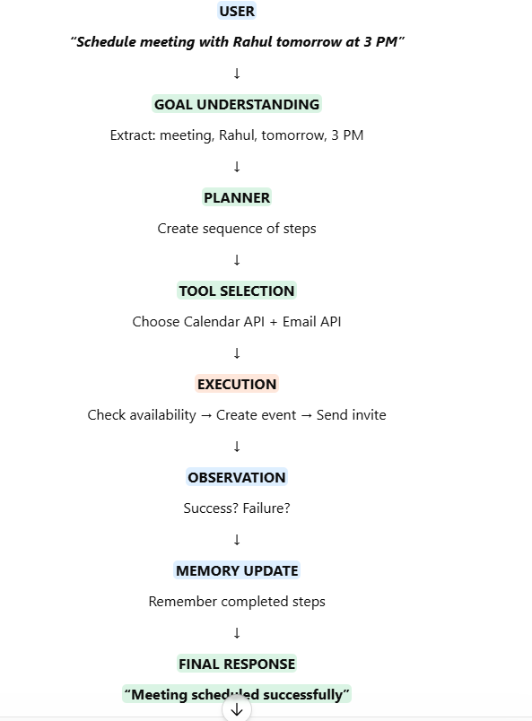
How does a LAM perform actions?
Let's use one example throughout.
User says:
"Order a large Margherita pizza from Domino's."
Now imagine you're the LAM.

Step 1: Receive the Goal
Input:
Order a large Margherita pizza from Domino's.
At this point, nothing has happened yet.
The LAM simply receives the instruction.

Step 2: Convert the Goal into a Plan
The planner thinks:
Goal:
Order pizza

Steps:
1. Open browser
2. Go to Domino's website
3. Search Margherita pizza
4. Select Large size
5. Add to cart
6. Proceed to checkout
7. Ask user for payment confirmation
8. Place order
Notice something important:
The planner doesn't know how to click.
It only creates the plan.
Think of it like an architect creating a blueprint.

Step 3: Which Tool Should I Use?
The planner now asks:
"Which tool can execute Step 1?"
It checks the available tools.
Task | Tool
Open Chrome | Browser Tool
Search website | Browser Tool
Call API | API Tool
Read PDF | PDF Tool
Query database | Database Tool
Run Python | Python Tool
For this task:
Selected Tool:
Browser Tool
This is called Tool Selection.

Step 4: The Browser Tool Starts
The browser automation tool is now responsible.
Think of it as a robot controlling a mouse and keyboard.
It performs actions such as:
Open Chrome
↓
Go to:
https://www.dominos.co.in
↓
Wait for page to load.
The LAM waits until the page is ready.
Step 5: Observe the Screen
Now imagine you're looking at the Domino's webpage.
A human sees:
- Search box
- Menu
- Images
- Buttons
- Login option
How does the LAM "see" this?
It doesn't see like humans.
Instead, it gets structured information such as:
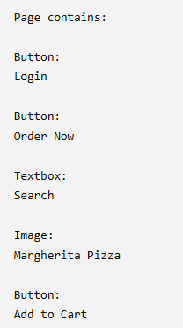

Step 6: Decide the Next Action
The planner now asks:
"Which object should I interact with?"
It sees:
Button:
Order Now
Decision:
Click
The executor performs:
Mouse Click

Step 7: Observe Again
After clicking, the page changes.
The LAM doesn't assume success.
It checks again.
Now it sees:
Search Box
Decision:
Type:
Margherita
Executor:
Keyboard Input:
Margherita

Step 8: Search Results
Now the page shows:
Margherita
Large
Medium
Small
Planner decides:
Click Large
Executor clicks.
Again it observes.

Step 9: Add to Cart
The page now has:
Button:
Add to Cart
Planner:
Next action:
Click Add to Cart
Executor clicks.
Observe.
Cart updated.

Step 10: Checkout
Planner:
Proceed to Checkout
Executor:
- Click Checkout
- Wait
- Observe

Step 11: Payment
Here is an important safety point.
Most LAM systems do not automatically make payments.
Instead, they stop and ask:
"Everything is ready. Would you like me to proceed with payment?"
This prevents unauthorized purchases.

Why is Observation Necessary?
Suppose the website changes.
Yesterday:
Button:
Order Now
Today:
Button:
Start Order
A hard-coded script might fail.
But the LAM observes the current page and can reason:
"'Order Now' isn't here, but 'Start Order' probably means the same thing."
So it clicks the correct button.
This makes LAMs much more adaptable than traditional automation scripts.

Where Do These "Actions" Come From?
A LAM doesn't physically move your mouse.
Instead, it uses tools that expose actions such as:
click()

type()

scroll()

hover()

select()

drag()

upload()

download()

press_enter()
The executor calls these actions whenever the planner requests them.

